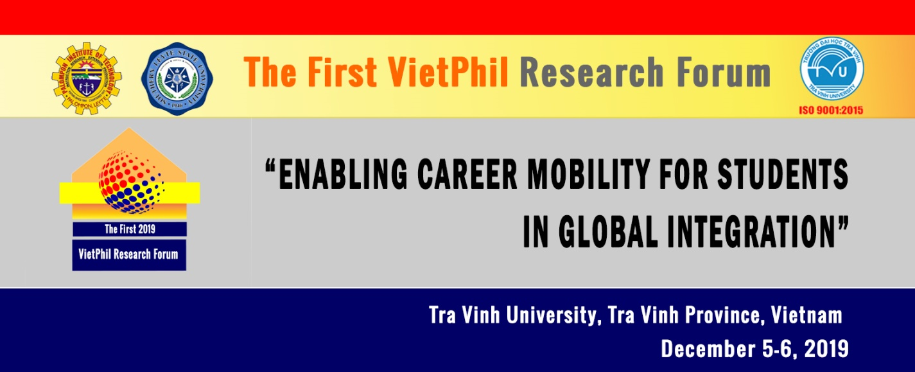

Call for Papers
The first VietPhil Research Forum 2019 will be organized by Tra Vinh University of Vietnam, Palompon Institute of Technology and Southern Leyte State University of the Philippines. The forum will be then held annually in either in Vietnam or the Philippines to provide a platform for the sharing of best practices, latest updates and prospects in tertiary education.
The first VietPhil Research Forum 2019 will be held on 5-6 December 2019 at Tra Vinh University, Vietnam with the theme, “Enabling Career Mobility for Students in the Global Integration”.
VietPhil Research Forum 2019 will give researchers, educators and teachers from Vietnam, the Philippines and the world the opportunity to share research results, teaching practices and experiences regarding increasing employment chances for students in the world labour market. VietPhil Research Forum will strive hard to make this professional development opportunity accessible to Vietnamese and Filipino teachers of English and teachers from other parts of the world.
VietPhi Research Forum now invites researchers, educational managers, educators and classroom teachers to send their papers and present at the forum. All presenters are encouraged to read the Call-for-Paper guidelines which is attached to this call for papers before submitting an abstract for consideration for presentation at the 1st VietPhil Research Forum 2019.
Time and Venue
Time: 2 days, 05-06/12/2019 (Thursday and Friday).
Venue: Tra Vinh University, 126 Nguyen Thien Thanh Street, Ward 5, Tra Vinh City, Tra Vinh Province.

Fee
Registration fee: USD 60 (applied for both presenters and participants)
Full text publication: free publication for the participants and presenters
Publication
Quality full papers will be blind reviewed and published in a special issue of Tra Vinh University Science Journal.
Key dates
The first VietPhil Research Forum 2019 will be held on 5-6 December 2019. The theme: “Enabling Career Mobility for Students in the Global Integration”

Key dates
Abstract sibmission close | 10 October 2019
Abstract selection outcome | 18 October 2019
Full papers submission for publication | 15 November 2019
Registration | 01 October – 4 December 2019
VietPhi research Forum Official Opening | 5 December 2019 (in the evening with a welcome dinner)
Main forum sessions | 5 – 6 December 2019
Mekong Cultural Tour (Optional) | 7 December 2019

Streams
The 1st VietPhi research forum 2019 will be held on 5-6 December 2019, under the theme ‘Enabling Career Mobility for Students in the Global Integration’. This is a multi-discipline international forum covering a variety of topics so that presenters from different disciplines can share their research results and teaching experiences. Areas of the forum are as follows.

Main forum areas
Education | Economics
Engineering and Technology | Environment
Agriculture and Aquaculture | Big data analytics
Others

Contact
For further information, please contact Dr. Phung Van De, the coordinator of the Forum.
Email: dephung@tvu.edu.vn
Phone: +84 2943855959 or Cell +84 919535559
Postal address: Center for International Education Development – RDI, Tra Vinh University, 126 Nguyen Thien Thanh Street, Ward 5 Tra Vinh City, Tra Vinh Province, Vietnam.

CALL FOR PAPERS GUIDELINES
Session or Paper Title: The title should not be more than 120 characters or about 25 words. First letters only should be capitalised except for proper names and with no punctuation.
Type of Session: For the Main Conference, the format of the presentation can be a 30 minute paper, or a 30 minute workshop. All sessions should relate to the published focus areas and theme of the conference.
- Paper: is presenter-centred and discusses issues related to ELT with reference to theory. Participation from attendees is limited.
- Workshop: provides practical professional development activities. Participants take an active part in activities.
Focus Areas: The Forum consists of 6 focus areas or streams in total.

Main forum areas
Education | Economics
Engineering and Technology | Environment
Agriculture and Aquaculture | Big data analytics
Others
Equipment: IT equipment is NOT available for poster sessions. With or without equipment, handouts are recommended and 60 copies are adequate for most sessions.
Abstract: Please enter your session or paper abstract using the form attached to this guideline. The abstract length has to be no more than 350 words. Please note that, if successful, this abstract will be printed “as is.” However, the conference organisers retain the right to make changes.
Please refer to following points when writing abstracts.
1. Make sure your title matches your abstract.
2. Please use plain text only with a single space; do not format your paragraph with bullet marks or line breaks between paragraphs.
Speaker information: Please list all speakers, their details and biography in the Call for Papers. It should be noted that only up to 3 speakers are allowed. In filling out the form, please consider the following points:
1. All communication will be made through the first speaker. The names of speakers will appear in the same order as in the Call for Papers.
2. Names should be written with only the first letter of each name being capitalised.
Biography: This information is to be included in Conference Handbook. Please consider the following points when writing your biography. The biography should contain no more than 120 words.
1. Your biography should contain your family name (with all capitalised letters) and your given name (with the first letter capitalised) i.e. PHUNG De.
2. You should include current workplace, publications (if any), career highlight(s) and area(s) of professional interest.
3. Write in third person.
4. Please use plain text only with a single space; do not format your paragraph with bullet marks or line breaks between paragraphs.

Abstract Submitting Form
- Forum |  | 1st VietPhil Research Forum on Tertiary Education  “Enabling Career Mobility for Students in Global Integration”  5-6 December 2019, Tra Vinh University, Vietnam
- Title of paper/ workshop
For more than one author, please copy and paste the following nine (Sections 3 – 11) rows for each additional author (upto 03 authors)
- Title |  | Dr Mr Ms Other Specify:
- First Name
- Family Name
- Position
- University/
Organization
- Country
- E-mail
- Phone/
Fax
- Biography
Abstract
Please try to limit your abstract to less than 350 words
Keywords
(at least three)

